|  |
| --- |
| **Saxion University of Applied Sciences** |
| WEEK 1 VHDL |
| VHDL 2018-2019 |
| **Project Plan**  **Project Integration 2019-2020**  *Author: D. Rangelov, A. Belyakov,* *Y. Chen,* *T. Cao, J. Qazi*  *Tutor: R. Kirmali, J.S.D Stokkink, U. Guler*  *Version: 0.0.1* |
| **Author : Dimitar Rangelov Student number 445392** |
| Tutor: J.S.D. Stokkink |

Version 0.0.1



|  |
| --- |
| The project plan will explain the fundamentals of project integration. One of the first things that will be explained is what the assignment is and what the exact requirements for this assignment are. Afterwards some basic administrative tasks need to be taken care of, such as dividing the different roles and creating a planning. |

**Names & Addresses**

|  |  |  |  |
| --- | --- | --- | --- |
|  | **Arsenii Belyakov** | 450835 | 450835@saxion.nl |
|  | **Dimitar Rangelov** | 445392 | 445392@saxion.nl |
|  | **Yiming Chen** | 423960 | 423960@saxion.nl |
|  | **Tianru Cao** | 454286 | 454286@saxion.nl |
|  | **Junaid Qazi** | 443406 | 443406@saxion.nl |



# Foreword

Project Integration will be the fifth and final project that we will do while being a student at Saxion.

The previous projects have taught us many different things, most importantly what the fundamentals of an engineering project are and how to effectively cooperate in a team.  
Hopefully we can bring all the knowledge we have previously gained together in Project Integration.

This will be the most challenging project yet, but we are excited for the opportunity and hopefully we will deliver a product that we can all be proud of.



# Summary

The project plan will explain the fundamentals of project integration.  
One of the first things that will be explained is what the assignment is and what the exact requirements for this assignment are.Afterwards some basic administrative tasks need to be taken care of, such as dividing the different roles and creating a planning.

Finally the methodology for solving the assignment will be chosen and this choice will be substantiated.

The goal of the project plan is to give the project group a base from which the project can start.  
If there are any problems during the project, the group can use the project plan as a guide or reference to stay on the right track.



**Contents**

Foreword 2

Summary 3

Introduction 5

1. Project Result 6

2. Activities 7

3. Boundaries 8

4. Quality 9

5. Team Organization 10

6. Planning 11

7. Scheduling 12

7.1 Schedule Development 12

7.2 Units of Measure and Level of Accuracy 12

7.3 Schedule Maintenance 12

7.4 Control Thresholds 12

7.5 Schedule Monitoring 13

7.6 Schedule Control 13

7.8 Scheduling – Gantt Chart 13

8. Cost & Benefits 14

8.1 Costs 14

8.2 Benefits 15

9. Risks 16

10. Bibliography 17

11. Attachment 18



# Introduction

The assignment for ‘Project Integration’ is to create a ‘healthcare robot’ which can assist in certain tasks for a target group that will be chosen by the project members themself.  
Project integration is a project that lasts two modules, or one semester, and will start at the beginning of quarter 3 and will last till the end of quarter 4.

The project group exists of five second-year students of which three study electronics and information engineering (EIE) and two study applied computer science (ACS).  
Project integration has two main parts:

* Hardware
* Software

These two parts synergize with the specializations of the students participating which means that ACS students will handle most, if not all, of the software parts while EIE students do most, if not all, of the hardware parts.

Just like previous projects, the V-model will be used as the main method for designing and testing the end product.  
One difference with previous projects is that the V-model only will be used for the hardware part of the project.  
The software project will use the SCRUM-method which seems more appropriate for the given task.

The aim of the project is to broaden the students knowledge about different engineering principles while also teaching how to design a product from the ground up.  
Another aim would be to teach the students how to work with people from different fields.  
The teamwork and synergy between the hardware and software team will make or break the end result.



# 1. Project Result

This project is to produce a Healthcare System. The project has specific requirements that are given by the students. All students will be assigned a specialized role within the project. Each student will discuss and explain the work that they have conducted with other members of the project. This is to provide an understanding of each other’s work within side the project. Also each week the role of scrum and secretary will change, thereby everyone will have a chance to lead the project and note to progress made as well as discussed points. This will spread the work load equally. From this the project will be assessed, also an evaluation by our pears.

In this project the final product is a “Healthcare System “. Concept ideas will be recorded and a schematic will be produced on Multisim. By using Multisim a simulation can be conducted as well as showing all the connections that will need to be completed as well as the components used. Each week the project will be documented. Evidence of this will be a Log Book. Also the programming development will be recorded and stored in Github.

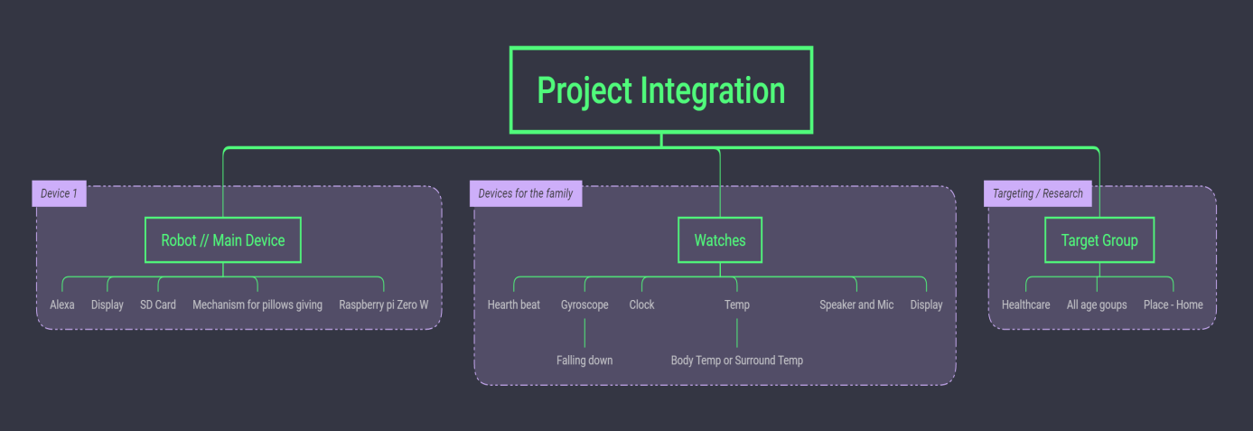

Fig Project Integration Plan

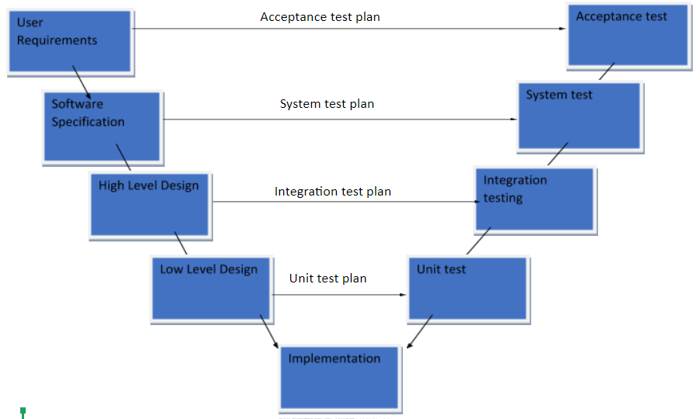

Fig V-model for the project



# 2. Activities

Our group has at least one or two meeting every week. These meeting will be discussed with all group members. During the discussion, we will discuss about existing issues and try to find a solution. In order to monitor progress and make recommendations on action. Each group members needs to contribute one of his or her own ideas and give some advice on the comments. And discuss group tasks for next week. This will help monitor the progress of the group.

Our work will be split into the following:

* Brainstorming for design our product
* Software part
* Hardware part

We need to know every step of the project, such as software design and hardware design. This is one of the most important factors to ensure the success of the project. If at the beginning of the project, we did not carefully check every step of the project, the consequences are very serious. Once the project was in the middle stage, it was found that the design at the beginning of the project was defective. This result was devastating to the project. This can lead to project failure and do not meet requirements.

For brainstorming, our team discussions use no constrained rules, every group members are able to think more freely and enter new areas of thought, resulting in a lot of new ideas and problem solving. When participants come up with new ideas and ideas, we come up with them, and we build on them. All views are recorded without criticism. Only at the end of the brainstorming session will these ideas and ideas be evaluated. Open the characteristics of brainstorming is to give participants thought that all kinds of ideas in the collision of mind creative storm, it can be divided into direct brainstorming and questioned the brainstorming method. It is a collective to develop creative thinking method. This can also make our project more successful.

For software part, We need to use C language or Python language for this project. Since we have not studied the python language systematically at school before, there may be many challenges. We also needed to use ESP32 and  we need to design analog input signals. We also need to complete some search and research, such as SPI I2C Webserver, Alexa. These are the projects we need to work on in terms of software. Before the project officially started, we had a lot of warm-up exercises. For example, the first task showed that ESP32 could turn on three different led lights and use an internal loop. This is done in python or c. The second task is to display the same as assignment 1, but this time using the serial interface to control the led. The assignment is more complex, but also more challenging. The third task displays the same content as task 2, but this time using WIFI or bluetooth, ask Google to go home or echo point to put an led with esp32. The difficulty of these assignments is progressive, so we think these warm-up exercises can make us familiar with the purpose of this project. If we don't know enough about the project, we won't be able to meet the requirements.

For the hardware part, We need to design and produce PCB is the main activity, there are risks. In the warm-up operation, we were required to design a PCB board first. If the design of PCB board and welding components to the PCB board were not completed, the final project would not work. So it will be seen as a failure. If welded correctly, the connection should work as planned and be able to complete the tasks set up in the final demonstration. However, if the soldering is incomplete or the PCB design is incorrect or completed, the final demonstration will not produce the desired results for the user. Therefore, the project will not meet the requirements and must be abandoned.

In addition, with regard to software and hardware, we need to consider the conflicts between each function of the program. If these programs conflict, we won't be able to complete the project. Therefore, every program and design must be optimized.



# 3. Boundaries

Base on the requirements of the clients, project boundaries needs to be clear and definite. This is helpful for arrangement and planning and avoiding to do some over-limit things and wasting-time things. The above includes 4 fields:

1. Project goal: project group need design and complete a smart health care product with client’s requirements. This product can know the user’s health condition by detection of the smart device. In addition, Giving a warning when the situation is not good, asking for help urgently when in a dangerous condition. From receiving client’s requirements to finishing a normal-running good, this period only has 17 weeks. It is meaning that group members should finish the project corporately and high-efficiently because of this tight time.
2. Key project stage: product’s function design, substructure integration and project test are key project stages. The functional design represents the whole design idea and the main direction. Due to the various functions of the design product, which is also divided into software and hardware design, the matching and integration of all the sub-structures are particularly difficult and important. The success of the test determines the success and failure of the final product.
3. Product range: The customer requires the product to have the function of speech recognition and dangerous help. The customer did not specify other specific functions, but due to the variety of similar products in the market, the project team needs to design products with use value and market competitiveness. Also, the customer clearly pointed out that the use of ESP32 module for intelligent control, so our entire design needs to be around the ESP32 module to carry out.
4. Team responsibilities: Due to the short project cycle, the assignment of team members' responsibilities is particularly important. Moreover, each member should have a sense of responsibility ，devote himself to the teamwork, communicate actively and cooperate with other members to complete the work.
5. Actively communicate with customers to confirm whether each step meets the requirements of customers. When there is any objection, focus on customers' ideas and adjust project boundaries.



# 4. Quality

The main paradigm for this project will be V-model. The product’s quality will be judged according to if the key requirements set by the client be met or not. Below you can find a list of the most important quality parameters which will be used as a guidance for this project.

1. By following the V-model, at the end of each module, the tests will be used to decide if the product follows all of the criteria set by client. Every module of the product has to work with other modules, and as a result this will give us a clear vision on the end goal of the project.
2. Every time in the end of each phase there will be a meeting with the product owner for progress discussing. This will be made for product quality assurance.
3. One of the most important parts is components. Our team has to make a research and use best and only the best available components. The main goal of this product is to provide an assistance in health care, what means that it should be reliable.
4. Accuracy is another key point of the products quality. This robot should be able to identify the user and provide the right medicine for him, otherwise it could be really dangerous for the end user, by getting the wrong pills or wrong amount of them.
5. A really important way to assure quality is to have clearly understandable and consistent feedback from the client and the project plan. By this when the questions cause by the team members, they will be able to solve them with the minimal loss in time and make sure that the product meets all of the product owner’s requests.
6. To account quality and consistency, any change or deviance by any team member on the main norms within organization, research or development has to be fully explained to each team member. By this way the product will fully follow to all of the client’s wishes, without any unexplainable changes.



# 5. Team Organization

For organizing the team to its fullest potential, we are opting to rotate the roles of the the secretary position. The main goal of a chairman is to schedule and lead the weekly appointments where all members have to address any of their progress, to-do lists, obstructions, objections and concerns as far as the project is concerned. The role of the secretary is write down the key points of each member and have it addressed at the next meeting to make sure that the member’s hinder was solved. This way the team can assure a fast and steady pace when working on the project. The chairman in this team is the student Dimitar Rangelov.

Within the group there are members within the Dutch and International lane of the EPA and EIE studies. Each member’s study variant will be shown in the table below.

|  |  |
| --- | --- |
| EIE Students | ACS Students |
| Dimitar Rangelov | Arsenii Belyakov |
| Junaid Qazi | Yiming Chen |
| Tianru Cao |  |

Tab Team organization table

Every member will be responsible for the project where their main study is the most relevant, e.g. the programming ACS and the PCB part and hardware part the EIE students. Since every team member is equally qualified to work on the project we assume everyone takes the tasks where they have the most knowledge over. This way everyone is seated in the best position they can get.



# 6. Planning

|  |  |  |  |  |
| --- | --- | --- | --- | --- |
| **Phase** | **Activities** | **Responsible member** | **Starting week** | **Deadline** |
| Project Plan | Research the assignment.  Divide the project plan under all group members. | All members | Week 3.1 | Week 3.2 |
| First Design Phase | In quarter 3 the EIE students and ACS students will need to complete individual assignments. EIE students will design a PCB for an audio amplifier while ACS students will work on different tasks related to programming the ESP32 microcontroller. | Individual | Week 3.1 | Week 3.2 |
| First Assemble Phase | EIE students will assemble the previously designed PCB while the ACS students will finish the code for their assignments. | Individual | Week 3.2 | Week 3.2 |
| Functional  Design | Defining the requirements of the end product and creating multiple concepts of which one will be chosen as the main product. | All members | Week 3.3 | Week 3.6 |
| Technical Design | Elaborate on the previously defined requirements and explain how the different technical parts (electronic, mechanical and software) of the design work. | All members | Week 3.7 | Week 3.8 |
| Assembly Phase | Assemble the ordered components and test the designed concept. | All members | Week 4.1 | Week 4.3 |
| Implementation Phase | Realize a final (working) product based on feedback from the assembly phase. | All members | Week 4.4 | Week 4.5 |
| Final Documentation Phase | Create a final report in which the concept is shown working together with measurements. Afterwards a logbook is created as a way to prove how many hours each student spent on the project. | All members | Week 4.5 | Week 4.6 |
| Assesment | Assesment during which the students prove to the supervisors that the end product is working according to the given requirements | All members | Week 4.7 | Week 4.7 |

Tab Planning table



# 7. Scheduling

We managed the time of this project with Trello software. Each team member has a Trello histogram, which clearly indicates the type of task and the deadline of tasks. The duration of the mission will be measured in days or weeks as appropriate.

## 7.1 Schedule Development

The project schedule will be based on the task allocation table after the group discussion, which is mainly managed by Trello. The team leader and secretary will determine the duration of the task associated with each task. They will also conduct correlation analysis to determine in what order the work must be done. Tasks associated activities, and duration are entered into the project schedule software tool and the first and second tasks are assigned at the activity level. The task size will be within the scope of the work package identified by the project, including the workload and duration. Named resources are assigned to each task. If the named resource is unknown, the resource group is assigned to the task.

## 7.2 Units of Measure and Level of Accuracy

The client required each member of our team to work at least 8 hours per week without any additional hours. Human resources are measured in hours, days, weeks, and months. This project does not use other parts or parts of the identified measures. In order to measure the activity duration of project resources, the project accuracy level is considered to be plus or minus 8%. Our team members need to work at least 10 hours a week.

## 7.3 Schedule Maintenance

Project team members use Trello(including deadline to each tasks) to maintain their tasks. Weekly to report their work time and progress. Train team members on how to log time. If a team member's task is not completed, the team must discuss the situation and complete it in time. This will help the team to better meet the customer's requirements and complete the product.

## 7.4 Control Thresholds

This section is described as a schedule variance threshold agreed upon by the project. The team chair and team will meet to review and evaluate the changes if the team members feel it is necessary to change the plan. The project team determines which tasks are affected, calculates the probability of their occurrence, and generates a list of alternatives to consider.

## 7.5 Schedule Monitoring

Each team member reports to the team leader weekly on the progress of the team's tasks. Each team member will update the project progress monthly, update the team members' work progress on the trello table, and inform the team leader of the overall status of the project progress when the project progress deviates from the plan.

## 7.6 Schedule Control

We used the Critical path method to control the progress of our team project. Optimizing the critical path is an effective method to improve the design speed. In general, the delay from input to output depends on the maximum delay path taken by the signal and is independent of other paths with small delay. Critical path method can be used repeatedly in the process of optimization design until it is impossible to reduce the critical path delay. This approach allows us to better control the progress of the project.

## 7.8 Scheduling – Gantt Chart

A gantt chart is a chart that can be used to show the progress of a project. This diagram lists the tasks to be performed on the vertical axis and the time intervals on the horizontal axis. The width of the bars in the figure shows the duration of each activity. The gantt chart indicates the project start date and the project end date. And some information about the projects the team members are responsible for.

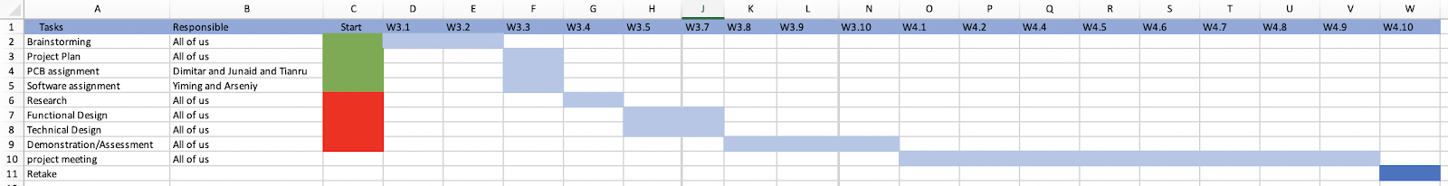

Fig Gant Chart for the project integration



# 8. Cost & Benefits

## 8.1 Costs

Product Design Cost

|  |  |  |  |  |
| --- | --- | --- | --- | --- |
| No. | Component | Quantity | Price/per,€ | Total price/€ |
| One Main device | | | | |
| 1 | ESP32 | 2 | 7 | 14 |
| 2 | Raspberry Pi zero w | 2 | 15 | 30 |
| 3 | Pill machine | 2 | 50 | 100 |
| 4 | microphone | 2 | 2 | 4 |
| 5 | speaker | 2 | 2 | 4 |
| 6 | OLED display | 2 | 2 | 4 |
| 7 | Battery | 2 | 5 | 10 |
| 8 | PCB board | 2 | 20 | 40 |
| 9 | SD card | 2 | 15 | 30 |
| 10 | Shell | 1 | 50 | 50 |
| 11 | other components | 1 | 100 | 100 |
|  | total |  |  | 386 |
| Three Watches | | | | |
| 1 | Gyroscope sensor | 5 | 25 | 125 |
| 2 | Temperature sensor | 5 | 20 | 100 |
| 3 | Heart rate sensor | 5 | 8 | 40 |
| 4 | ESP32 | 5 | 7 | 35 |
| 5 | microphone | 5 | 2 | 10 |
| 6 | speaker | 5 | 2 | 10 |
| 7 | OLED display | 5 | 2 | 10 |
| 8 | Battery | 5 | 5 | 25 |
| 9 | PCB board | 1 | 40 | 40 |
| 10 | Shell | 1 | 80 | 80 |
| 11 | other components | 1 | 100 | 100 |
|  | total |  |  | 575 |
| Technical Design | | | | |
| 1 | Expenses |  |  | 5000 |
| Research & Development person | | | | |
| 1 | Salary |  |  | 17000 |
|  |  |  |  |  |
|  | total |  |  | 22961 |

Tab 3 Cost table

The above is the total estimated cost from the product ‘s research and development to finished products, totalling 22,961 euros. The number of components that exceed the production is given in it. In this way, on the one hand, there will be component losses and broken during the manufacturing and testing process; on the other hand, sufficient supply of components will not affect the production period. The technical design fee is to continuously improve the product to have a better use experience. Research & Development person salary is the estimated price based on the total hours worked by the employee multiplied by the hourly wage（salay=17weeks*5days*2 hours*5 people*20 euros=17000 euros）.

## 8.2 Benefits

Since there are few products completely similar to this product in the market, the market product is only a single good，smart watch, AI voice assistant or smart medicine box, so this product combines the above functions, which is special in the market. In particular, there is almost no intelligent pillbox in the Dutch market, and most of the search results are based on the old electronic technology. There are less than 10 similar products in the Chinese market. In addition, a smartwatch with temperature measurement and falling monitor function is also a very unusual design. So the project products should have great market competitiveness. The project team conducted a price search for single function products in the market and gave the following evaluation prices and reference products. It is conservatively estimated that the market price of the project product is 200 euros

1. Smart pill box:€60-200;

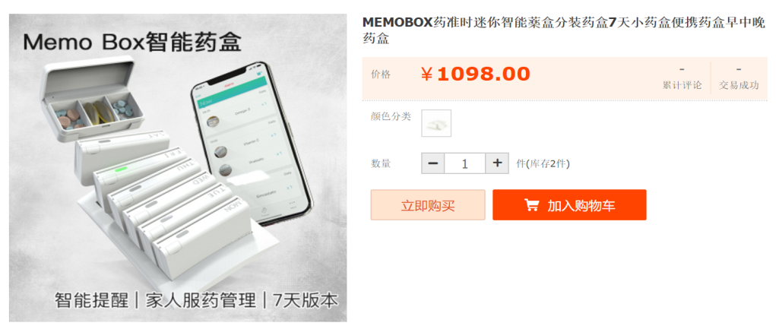

Fig A smart medicine box fromTaobao.com in China costs the equivalent of 138 euros [1]

1. AI voice assistant:€50-80;



Fig AI voice assistant from amazon.com in Germany [2]

1. Smartwatch:€50-120;

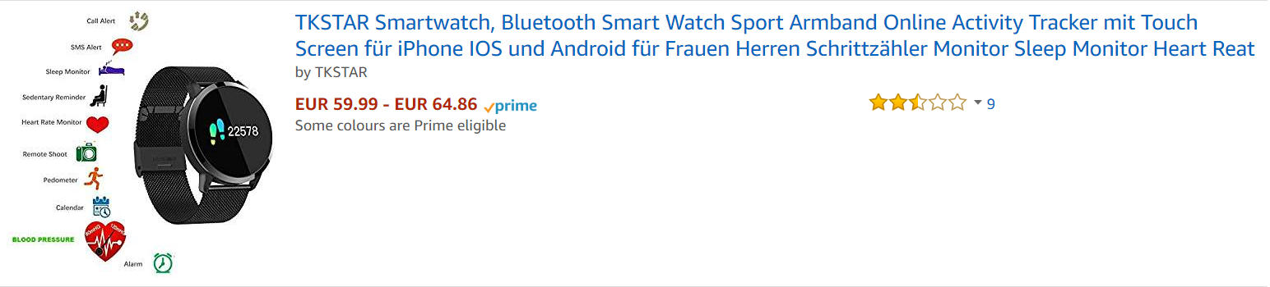

Fig Smart watch from amazon.com in Germany [3]



# 9. Risks

Each project development process contains risks. This is the reason why we are making a risk analysis, so by this we can prevent or at least reduce the chances of failure. The way how we can achieve this is by writing down together what can be a problem and what can go wrong. By knowing risks we can get more prepared for them and try to prevent them.

In every company or project there are chances or risks. This is why we make a risk analysis so we can reduce the chances of failure. We can achieve this by writing down together what can be a problem and also what can go wrong. Being prepared is better than regretting lost time.

The risks can be broken down into main two types: internal and external. With the following tables we focus most to the first type (internal).

The table is located as an attachment. See page 18.



# 10. Bibliography

|  |  |
| --- | --- |
| [1] | Taobao. Available: https://item.taobao.com/item.htm?spm=a230r.1.14.1.7c1c3986jqTove&id=565951622284&ns=1&abbucket=16#detail. |
| [2] | „Amazon,“ Alexa Amazon . Available: https://www.amazon.de/Amazon-Echo-Dot-Intelligenter-Lautsprecher-Alexa/dp/B0792HCFTG/ref=sr_1_4?s=amazon-devices&ie=UTF8&qid=1551029572&sr=1-4&keywords=echo. |
| [3] | „Amazon,“ TKSTAR smartwatch. Available: https://www.amazon.de/dp/B0756964SS/ref=twister_B07JWGHXKB?_encoding=UTF8&psc=1. |



# 11. Attachment



Tab 4 Risks table





Tab 5 Category with maximum score vs actual score

Tab 6 Risk analyzes graph